

SailPoint IdentityNow Requirements and Solution Document

For:
[Client]

[Date]

Submitted by:
[Preparer Name]
[Preparer Job Title]
SailPoint Technologies, Inc.
[Preparer Email]

Contents

1. Contents 2
2. Version History 5
3. Reference Documents 6
4. Introduction 7
4.1 Scope 7
4.2 Communications Architecture 7
4.3 Data Flow Diagram 9
5. Virtual Appliances 10
5.1 Deployment Options 10
5.2 Configuration Options 10
6. Source Configurations 11
6.1 <Authoritative Source Name> 11
6.1.1 Account Schema 11
6.1.2 Requirements 12
6.1.3 Solution Design 13
6.2 <Target Source Name> 13
6.2.1 Account Schema 13
6.2.2 Requirements 15
6.2.3 Solution Design 15
6.3 Example AD 16
6.3.1 Account Schema 16
6.3.2 Requirements 17
6.3.3 Solution Design 18
6.4 Example Azure Active Directory 18
6.4.1 Account Schema 18
6.4.2 Requirements 19
6.4.3 Solution Design 19
6.5 Example ServiceNow 20
6.5.1 Account Schema 20
6.5.2 Requirements 21
6.5.3 Solution Design 21
6.6 Example OpenLDAP 22
6.6.1 Account Schema 22
6.6.2 Requirements 23
6.6.3 Solution Design 23
7. Password Management 23
7.1 Azure Active Directory 23
7.1.1 Solution Design 24
8. Provisioning 25
8.1 Active Directory 25
8.1.1 Joiner Requirements 25
8.1.2 Joiner Solution Design 25
8.1.3 Mover Requirements 26
8.1.4 Mover Solution Design 26
8.1.5 Leaver Requirements 26
8.1.6 Leaver Solution Design 26
8.2 Azure Active Directory 26
8.2.1 Joiner Requirements 26
8.2.2 Joiner Solution Design 27
8.2.3 Mover Requirements 27
8.2.4 Mover Solution Design 27
8.2.5 Leaver Requirements 27
8.2.6 Leaver Solution Design 27
9. Additional Features 28
9.1 Branding Requirements 28
9.2 Access Requests Requirements 28
9.3 Certifications Requirements 28
9.4 Separation of Duties Requirements 29
10. Integrations 30
10.1 ServiceNow SIM (Ticket) Integration 30
10.1.1 Requirements 30
10.1.2 Solution Design 30
11. Appendix A: Audit 31
12. Appendix B: Assumptions and Risk 32
13. Appendix C: Data Retention 33
14. Appendix D: IQ Service 34
15. Appendix E: Password Interceptor 35
16. Appendix F: Desktop Password Reset 36

Version History

Version | Date | Name | Description
1.0 |  |  | Initial Draft
Signoff |  |  | Requirements Signoff
Signoff |  |  | Solution Design Signoff

Reference Documents

ID | Document
1
2
3
4

Introduction
This document is a representation of the architectural decisions, gathered requirements, and technical solution for [Client]’s implementation setup of IdentityNow. The intent is that, after each phase of the onboarding process – architectural review, requirements gathering and solution design – the client will sign off on the delivered documentation so that the technical engagement teams on both the client and IdentityNow side have a clear direction for the org build-out.

Please note: All object names (sources/attributes/roles/access profiles) are subject to change during build out. Objects in this document should serve as a guide for configuration. The As-Built documentation will serve as the configuration specification.

Scope
- Sources
  - <List out Sources to configure>
- Password Management
  - <List of high level use cases: i.e. password reset/forgot password/password sync>
- Provisioning
  - <List of high level automated use cases: Joiner/Mover/Leaver on source, O365 Licensing, Attribute Sync>
- Certification
  - <List of high level certification use cases: Manager Campaigns/Source Owner Campaigns>
- Access Request / Roles <Remove if not included>
- Separation of Duties <Remove if not included>
- Integrations <Remove if not included>
  - <List of Integrations: i.e. ServiceNow/other SIM Integration, ServiceNow Catalog Integration>

Approach
The IdentityNow Sandbox tenant will be used for testing and training and will connect to the test systems in scope. Deviations to test setup will be noted here.

As a best practice: in parallel as part of the connectivity and foundation phase the IdentityNow Production tenant will be configured to aggregate and correlate production systems.

Communications Architecture
<Delete the 2 not selected>
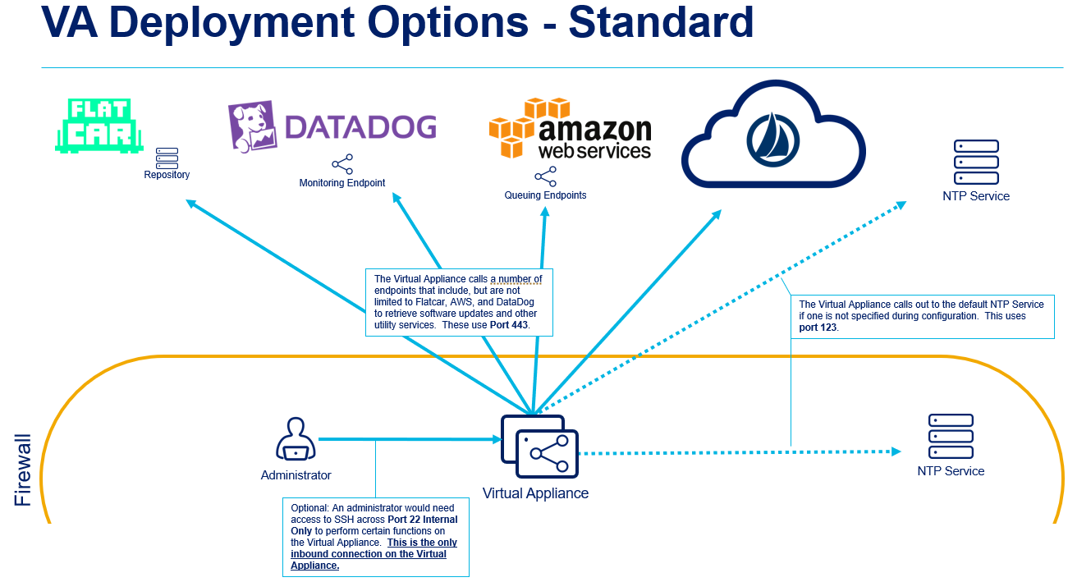

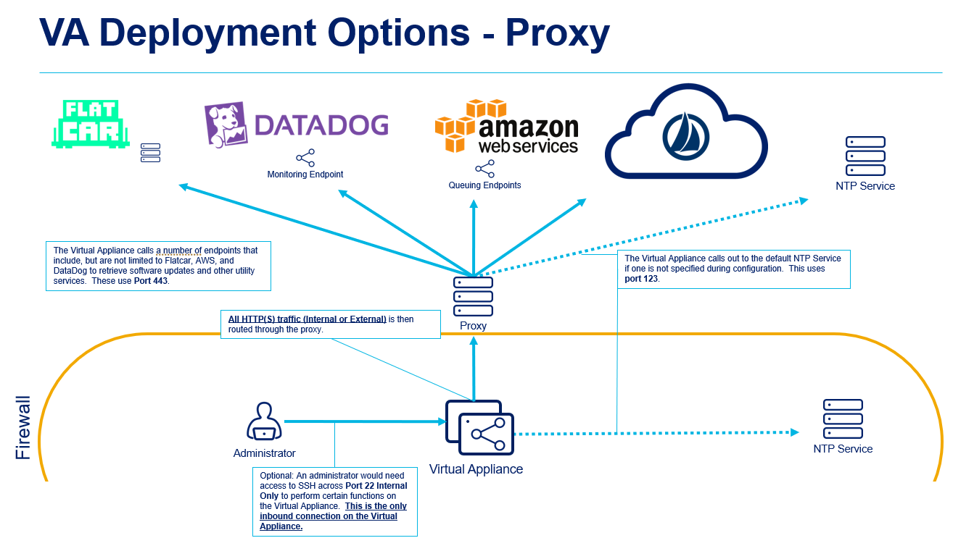

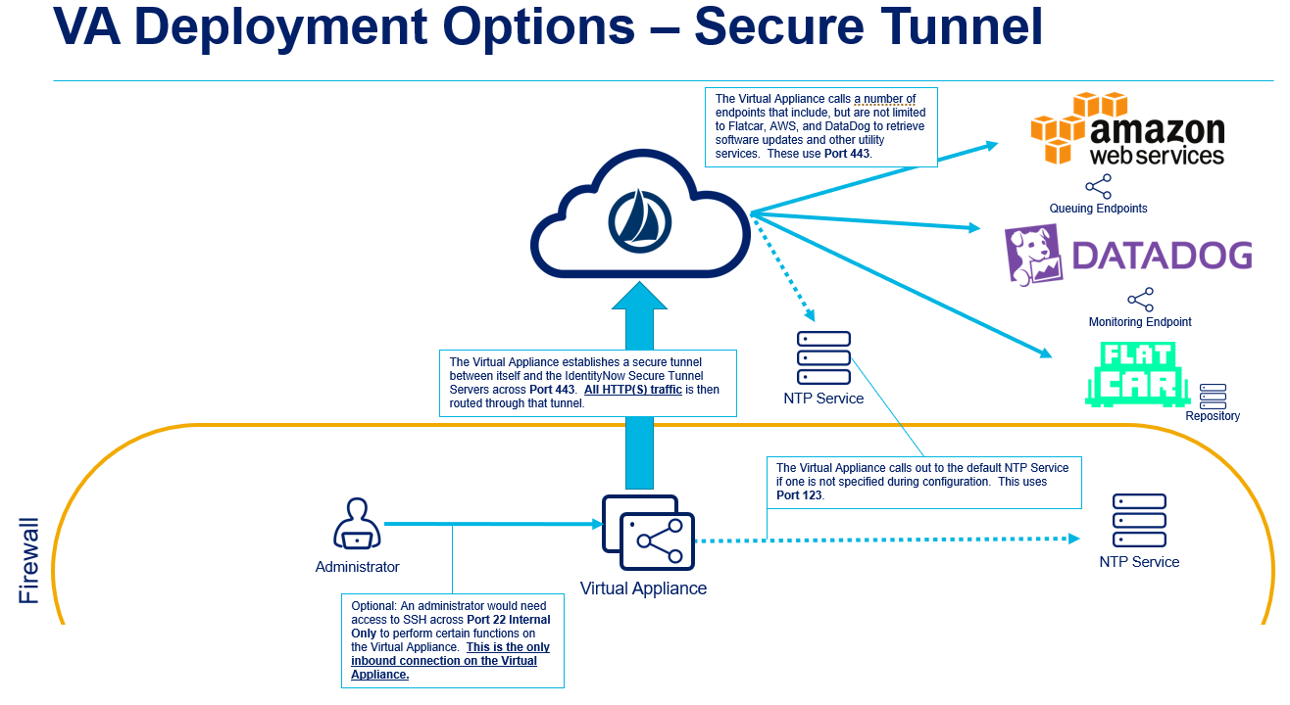

Data Flow Diagram
<Delete below and insert necessary diagram>
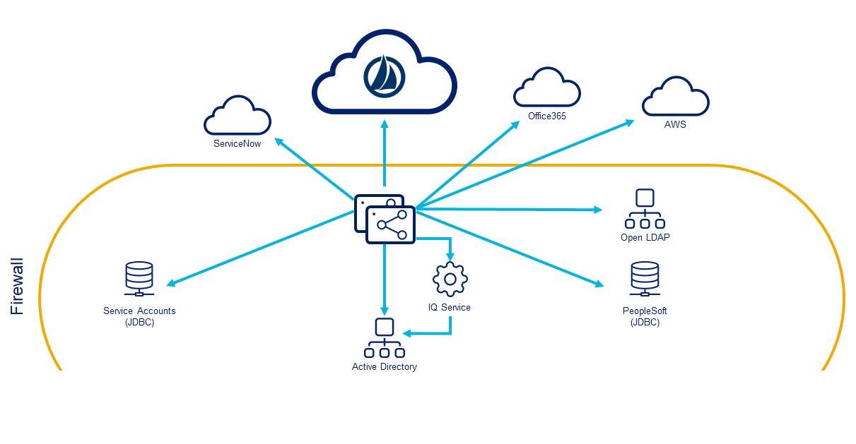

Virtual Appliances

Deployment Options
Option | Choice
Local with vSphere | <Delete this and Mark Selected on appropriate option>Selected
Local with Hyper-V
Cloud on AWS
Cloud on Azure

Configuration Options
Option | Technical Requirements | Choice
Standard | Open network traffic outbound across port 443. Cannot do deep packet analysis.
Proxy | Open network traffic outbound across port 443 through an unauthenticated Proxy. Cannot do deep packet analysis.
Secure Tunnel | Open network traffic outbound across 443 to 3 IP Addresses specified based on Tenant location. Cannot do deep packet analysis. | <Delete this and Mark Selected on appropriate option>Selected

Global System Configuration

System settings

Branding

Requirement | Requirement
BRANDING1.1 | IdentityNow will allow administrators to add branded colors
BRANDING1.2 | IdentityNow will allow administrators to add branded logos
BRANDING1.3 | IdentityNow will allow administrators to add a custom watermark under the login box
BRANDING1.4 | IdentityNow will allow administrators to add a custom message on the login screen
BRANDING1.5 | SailPoint will provide guidance on customization of email templates

Usage agreement

Requirement | Requirement
Agreement1.1 | IdentityNow will provide the means to add a usage agreement at initial login

Network Settings

Requirement | Requirement
NETWORK1.1 | IdentityNow will provide the means to whitelist / blacklist specific IP addresses or regions

System features

Requirement | Requirement
Features1.1 | IdentityNow provides the ability to show the enabled system features

System Notifications

Requirement | Requirement
NOTIFICATIONS1.1 | IdentityNow provides the ability to enable notifications and the receiver(s) default value:  Send to IdentityNow admins

Security settings

Security Questions

Requirement | Requirement
SECQUESTIONS1.1. | IdentityNow provides the ability to set security questions

Integrated Windows Authentication

Requirement | Requirement
IWA1.1. | IdentityNow provides the ability to enable IWA

Lockout Management

Requirement | Requirement
LOCKOUT1.1 | IdentityNow provides the ability to enable account lockout

Session Management

Requirement | Requirement
SESSION1.1 | IdentityNow provides the ability to enable session management

Redirect Patterns for sign-out

Requirement | Requirement
SIGNOUT1.1 | IdentityNow provides the ability to enable session management

E-mail templates

Requirement | Requirement
EMAIL1.1 | IdentityNow provides the ability to change the from address in emails
EMAIL1.2 | IdentityNow provides the ability to change the email templates default structure is;  From: no-reply@sailpoint.com  Subject: {as per e-mail request template for LCS/Access Certification/Access Request}

Source Configurations
This section denotes the source configuration requirements for [Client].

Note: For any indirectly connected sources below (i.e., delimited files), it is the client’s responsibility to set up regular aggregations/imports of those files into IdentityNow. This is to ensure that the data IdentityNow has within its system is up to date with any native changes done on the target system. SailPoint offers a File Upload Utility to assist in automating this process if the client so chooses.

Data Source | Connector Type | Source reference
<Source Name> | <Direct/Flat File> (Connector Type if Direct) | SOURCE1
HR | Flat File | SOURCE2
Active Directory | Direct (Active Directory Connector) | SOURCE3
Azure Active Directory | Direct (Azure AD Connector) | SOURCE4

<Authoritative Source Name>
<Any Description of the source useful for implementation>

Account Schema
The following attributes are going to be present in this authoritative source:

Name | Multi-Valued | Entitlement

Requirements
Based on the above attributes, the below requirements must be met:

ID | Description
SOURCE.HR.1 | All employees and contractors will be aggregated from the same feed
SOURCE.HR.2 | IdentityNow will calculate the Lifecycle State of each user based on a combination of the <List attributes> attributes of the incoming data feed:  - Prehire  - Pre Start Date  - Active  - Post Start Date and Pre End Date  - Inactive  - Post End Date
SOURCE.HR.3 | The accountID attribute in IdentityNow will be mapped to the <Account ID> attribute in the incoming data feed
SOURCE.HR.4 | The accountName attribute in IdentityNow will be mapped to the <Account Name> attribute in the incoming data feed
SOURCE.HR.5 | The Identity’s Manager will be mapped using the <Manager ID> attribute in the incoming data feed; this represents the manager’s <Identity Attribute to map to manager attribute> <Or complex rule logic>
SOURCE.HR.6 | <Any additional Write Back logic for the source>

Solution Design
<Example Solution for above requirements>
Requirement | Description
SOURCE.HR.1 | No solution required; all identities will be sourced from regular aggregations
SOURCE.HR.2 | A lifecycle state <IdentityAttribute rule/transform> will be utilized to match the requirements list above
SOURCE.HR.3 | No solution required; the account schema selection will be done via UI configuration
SOURCE.HR.4 | No solution required; the account schema selection will be done via UI configuration
SOURCE.HR.5 | The managerCorrelationMapping attribute on the source’s configuration settings will be set via API such that accountAttributeName=<attribute Name>, and identityAttributeName=<identity Attribute Name>:  {  “op": "replace",  "path": "/managerCorrelationMapping",  "value": {  "identityAttributeName": "<identityAttributeName>",  "accountAttributeName": "<accountAttributeName>"  }  }
SOURCE.HR.6 | Identity Attributes + Attribute Sync

<Target Source Name>
<Any Description of the source useful for implementation>

Account Schema
The following attributes are going to be present in this source:

Name | Composition and/or Data Type

Requirements
Based on the above attributes, the below requirements must be met:

ID | Description
SOURCE.EX.1 | IdentityNow will correlate accounts to the authoritative source data based on the following identity attribute to account attribute mappings. If unique user is not found, it will look at the next mapping  - <identity attribute key>: <account correlating key>  - <identity attribute key>: <account correlating key>  - <identity attribute key>: <account correlating key>
SOURCE.EX.2 | The accountID attribute in IdentityNow will be mapped to the distinguishedName attribute in Active Directory
SOURCE.EX.3 | The accountName attribute in IdentityNow will be mapped to the sAMAccountName attribute in Active Directory

Solution Design
<Example Solution for above requirements>
Requirement | Description
SOURCE.HR.1 | No solution required; all identities will be sourced from regular PeopleSoft aggregations
SOURCE.HR.2 | A lifecycle state IdentityAttribute rule will be utilized to do the requisite date math for the Prehire scenario, and also to map the PeopleSoft-provided worker status abbreviations to the appropriate lifecycle state value in IdentityNow if the user is no longer a Prehire
SOURCE.HR.3 | No solution required; the account schema selection will be done via UI configuration

Example AD

Account Schema
The following attributes are going to be present in this source:

Name | Multi-Valued | Entitlement
businessCategory | No | No
carLicense | Yes | No
cn | No | No
departmentNumber | No | No
description | No | No
destinationIndicator | No | No
displayName | No | No
distinguishedName | No | No
employeeNumber | No | No
employeeType | No | No
facsimileTelephoneNumber | Yes | No
givenName | No | No
homePhone | No | No
homePostalAddress | No | No
initials | No | No
internationaliSDNNumber | No | No
l | No | No
mail | No | No
manager | No | No
mobile | No | No
o | No | No
ou | No | No
pager | No | No
physicalDeliveryOfficeName | No | No
postOfficeBox | No | No
postalAddress | No | No
postalCode | No | No
preferredDeliveryMethod | No | No
preferredLanguage | No | No
registeredAddress | No | No
roomNumber | No | No
secretary | No | No
seeAlso | No | No
sn | No | No
st | No | No
street | No | No
telephoneNumber | No | No
teletexTerminalIdentifier | No | No
telexNumber | No | No
title | No | No
uid | No | No
objectClass | Yes | No
memberOf | Yes | Yes
objectSid | No | No
objectguid | No | No
sAMAccountName | No | No
primaryGroupID | No | No
primaryGroupDN | No | No
accountFlags | Yes | No
department | No | No
msNPCallingStationID | Yes | No
msRADIUSFramedRoute | Yes | No
msNPAllowDialin | No | No
msRADIUSCallbackNumber | No | No
msRADIUSFramedIPAddress | No | No
mailNickname | No | No
homeMDB | No | No
msExchHideFromAddressLists | No | No
msRTCSIP-UserEnabled | No | No
SipAddress | No | No
RegistrarPool | No | No
LyncPinSet | No | No
LyncPinLockedOut | No | No
pwdLastSet | No | No
msDS-PrincipalName | No | No
userPrincipalName | No | No

Requirements
Based on the above, the below requirements must be met:

ID | Description
SOURCE.AD.1 | IdentityNow will correlate Active Directory accounts to the authoritative source data by first comparing the EMPLID column in the PeopleSoft source to the employeeNumber attribute in Active Directory; if no match, we will compare the user’s shortname to the sAMAccountName in Active Directory; if no match, we will then compare the user’s EMP_EMAIL attribute in the PeopleSoft source to the mail attribute in Active Directory.
SOURCE.AD.2 | The accountID attribute in IdentityNow will be mapped to the distinguishedName attribute in Active Directory
SOURCE.AD.3 | The accountName attribute in IdentityNow will be mapped to the sAMAccountName attribute in Active Directory

Solution Design
Requirement | Description
SOURCE.AD.1 | No solution necessary; the account correlation settings will be done via UI configuration
SOURCE.AD.2 | No solution required; the account schema selection will be done via UI configuration
SOURCE.AD.3 | No solution required; the account schema selection will be done via UI configuration

Example Azure Active Directory

Account Schema
The following attributes are going to be present in this source:

Name | Multi-Valued | Entitlement
accountEnabled | No | No
assignedLicenses | Yes | No
assignedPlans | Yes | Yes
city | No | No
country | No | No
department | No | No
dirSyncEnabled | No | No
disabledPlans | Yes | No
displayName | No | No
facsimileTelephoneNumber | No | No
givenName | No | No
groups | Yes | Yes
immutableId | No | No
jobTitle | No | No
lastDirSyncTime | No | No
mail | No | No
signInNames | Yes | No
userIdentities | Yes | No
creationType | No | No
mailNickname | No | No
mobile | No | No
objectId | No | No
onPremisesSecurityIdentifier | No | No
otherMails | Yes | No
passwordPolicies | No | No
physicalDeliveryOfficeName | No | No
postalCode | No | No
preferredLanguage | No | No
proxyAddresses | Yes | No
roles | Yes | Yes
sipProxyAddress | No | No
state | No | No
streetAddress | No | No
surname | No | No
telephoneNumber | No | No
usageLocation | No | No
userPrincipalName | No | No
userType | No | No

Requirements
Based on the above, the below requirements must be met:

ID | Description
SOURCE.AZURE.1 | IdentityNow will correlate the Azure AD account to the identity by first comparing the user’s EMPLID from PeopleSoft to the TBD attribute in AzureAD; if no match, we will compare the user’s shortname to the mailNickname attribute in Azure AD; if no match, we will then compare the user’s EMP_EMAIL attribute in the PeopleSoft source to the mail attribute in Azure AD
SOURCE.AZURE.2 | The accountID attribute in IdentityNow will be mapped to the objectId attribute in Azure AD
SOURCE.AZURE.3 | The accountName attribute in IdentityNow will be mapped to the userPrincipalName attribute in Azure AD

Solution Design
Requirement | Description
SOURCE.AZURE.1 | No solution necessary; the account correlation settings will be done via UI configuration
SOURCE.AZURE.2 | No solution required; the account schema selection will be done via UI configuration
SOURCE.AZURE.3 | No solution required; the account schema selection will be done via UI configuration

Example ServiceNow

Account Schema
The following attributes are going to be present in this source:

Name | Composition and/or Data Type
first_name | String
last_name | String
email | String
user_name | String
department | String
title | String
sys_id | String
phone | String
calendar_integration | String
sys_class_name | String
company | String
cost_center | String
sys_created_on | String
sys_created_by | String
groups | String
active | String
building | String
city | String
country | String
location | String
manager | String
middle_name | String
name | String
password_needs_reset | String
default_perspective | String
sys_domain | String
employee_number | String
failed_attempts | String
gender | String
home_phone | String
ldap_server | String
preferred_language | String
last_login | String
last_login_time | String
locked_out | String
mobile_phone | String
notification | String
schedule | String
state | String
source | String
street | String
time_format | String
time_zone | String
sys_updated_on | String
sys_updated_by | String
sys_mod_count | String
vip | String
Zip | String

Requirements
Based on the above, the below requirements must be met:

ID | Description
SOURCE.SNOW.1 | IdentityNow will correlate the ServiceNow account to the identity by first comparing the user’s EMPLID from PeopleSoft to the employee_number attribute in ServiceNow; if no match, we will compare the user’s EMP_EMAIL attribute in the PeopleSoft source to the email attribute in ServiceNow
SOURCE.SNOW.2 | The accountID attribute in IdentityNow will be mapped to the sys_id attribute in ServiceNow
SOURCE.SNOW.3 | The accountName attribute in IdentityNow will be mapped to the email attribute in ServiceNow

Solution Design
Requirement | Description
SOURCE.SNOW.1 | No solution necessary; the account correlation settings will be done via UI configuration
SOURCE.SNOW.2 | No solution required; the account schema selection will be done via UI configuration
SOURCE.SNOW.3 | No solution required; the account schema selection will be done via UI configuration

Example OpenLDAP

Account Schema
The following attributes are going to be present in this source:

Name | Composition and/or Data Type
businessCategory | String
carLicense | String
cn | String
dn | String
departmentNumber | String
description | String
destinationIndicator | String
displayName | String
employeeNumber | String
employeeType | String
facsimileTelephoneNumber | String
givenName | String
groups | String
homePhone | String
homePostalAddress | String
initials | String
internationaliSDNNumber | String
l | String
mail | String
manager | String
mobile | String
o | String
ou | String
pager | String
physicalDeliveryOfficeName | String
postOfficeBox | String
postalAddress | String
postalCode | String
preferredDeliveryMethod | String
preferredLanguage | String
pwdReset | String
registeredAddress | String
roomNumber | String
secretary | String
seeAlso | String
sn | String
st | String
street | String
telephoneNumber | String
teletexTerminalIdentifier | String
telexNumber | String
title | String
uid | String
objectClass | String

Requirements
Based on the above, the below requirements must be met:

ID | Description
SOURCE.LDAP.1 | IdentityNow will correlate the OpenLDAP account to the identity by first comparing the user’s EMPLID from PeopleSoft to the employeeNumber attribute in OpenLDAP; if no match, we will compare the user’s shortname to the uid attribute in OpenLDAP; if no match, we will then compare the EMP_EMAIL in the PeopleSoft source to the mail attribute in OpenLDAP
SOURCE.LDAP.2 | The accountID attribute in IdentityNow will be mapped to the dn attribute in OpenLDAP
SOURCE.LDAP.3 | The accountName attribute in IdentityNow will be mapped to the uid attribute in OpenLDAP

Solution Design
Requirement | Description
SOURCE.LDAP.1 | No solution necessary; the account correlation settings will be done via UI configuration
SOURCE.LDAP.2 | No solution required; the account schema selection will be done via UI configuration
SOURCE.LDAP.3 | No solution required; the account schema selection will be done via UI configuration

SAP SuccessFactors

Account Schema
The following attributes are going to be present in this source:
Name | Multi-Valued | Entitlement
PersonID | No | No
Person ID External | No | No
Username | No | No
Userid | No | No
FormalName | No | No
Salutation | No | No
FirstName | No | No
MiddleName | No | No
LastName | No | No
PreferredName | No | No
Date Of Birth | No | No
Gender | No | No
Department | No | No
Division | No | No
Company | No | No
BusinessUnit | No | No
Location | No | No
Country | No | No
Nationality | No | No
PositionNumber | No | No
JobTitle | No | No
EmployeeType | No | No
EmployeeStatus | No | No
PrimaryEmailAddress | No | No
Job Classification | No | No
CostCenterID | No | No
IsContingentWorker | No | No
FLSA | No | No
AssignmentType | No | No
ManagerID | No | No
CostCenter | No | No
EmployeeClass | No | No
IsFullTime | No | No
ServiceDate | No | No
JobInfoLastModified | No | No
Position Entry Date | No | No
LastDateWorked | No | No
Address | No | No
BusinessPhone | No | No
BusinessPhoneCountryCode | No | No
BusinessExtension | No | No
CellCountryCode | No | No
Cell | No | No
Fax | No | No
FutureActions | No | No
Termination Date | No | No

Requirements

Requirement | Description
SOURCE.SAPF.1 | All full-time employees will be aggregated from this source
SOURCE.SAPF.2 | IdentityNow will calculate the Lifecycle State of each user based on the EmployeeStatus attribute in the incoming data feed:  - Active = “Active”  - Unpaid Leave = “Terminated”  - Terminated = “Unpaid Leave”
SOURCE.SAPF.3 | The accountID attribute in IdentityNow will be mapped to the PersonID attribute in the incoming data feed
SOURCE.SAPF.4 | The accountName attribute in IdentityNow will be mapped to the FormalName attribute in the incoming data feed
SOURCE.SAPF.5 | The worker’s manager will be correlated to the worker by comparing the ManagerID column in the incoming worker record to the PersonID column of the users list

Solution Design

Requirement | Description
SOURCE.SAPF.1 | No solution necessary; this is handled via out-of-the-box source configuration
SOURCE.SAPF.2 | A “ToLower” transform will be leveraged for the Lifecycle State identity attribute that takes the incoming EmployeeStatus attribute and renders it in the all-lowercase system name of the configured lifecycle state
SOURCE.SAPF.3 | No solution necessary; this is configured in the UI
SOURCE.SAPF.4 | No solution necessary; this is configured in the UI
SOURCE.SAPF.5 | The SuccessFactors’s source configuration will be updated via the below API call to set the manager correlation (note that this requires the Employee Number identity attribute to be mapped to PersonID):  [  {  "op": "replace",  "path": "/managerCorrelationMapping",  "value": {  "identityAttributeName": "identificationNumber",  "accountAttributeName": "managerID"  }  }  ]

Salesforce

Account Schema

Name | Multi-Valued |  | Entitlement
Id | No | No
Alias | No | No
City | No | No
CommunityNickname | No | No
CompanyName | No | No
CallCenterId | No | No
Country | No | No
Department | No | No
Email | No | No
Division | No | No
EmployeeNumber | No | No
Extension | No | No
Street | No | No
Fax | No | No
IsActive | No | No
IsFrozen | No | No
Username | No | No
FirstName | No | No
LastName | No | No
EmailEncodingKey | No | No
Name | No | No
UserPermissionsMarketingUser | No | No
UserPermissionsMobileUser | No | No
UserPermissionsOfflineUser | No | No
UserPermissionsSFContentUser | No | No
Phone | No | No
ProfileId | No | Yes
ProfileName | No | No
PublicGroups | Yes | Yes
QueueNames | Yes | Yes
ReceivesAdminInfoEmails | No | No
UserRoleId | No | No
UserRoleName | No | Yes
UserType | No | No
State | No | No
Title | No | No
ReceivesInfoEmails | No | No
PermissionSet | Yes | Yes
ManagerId | No | No

Requirements

Requirement | Description
SOURCE.SF.1 | IdentityNow will correlate the Salesforce account to the identity by comparing the Work Email identity attribute to the Email attribute in Salesforce
SOURCE.SF.2 | The accountID attribute in IdentityNow will be mapped to the Id attribute in Salesforce
SOURCE.SF.3 | The accountName attribute in IdentityNow will be mapped to the Username attribute in Salesforce

Solution Design

Requirement | Description
SOURCE.SF.1 | No solution necessary; this is configured in the UI
SOURCE.SF.2 | No solution necessary; this is configured in the UI
SOURCE.SF.3 | No solution necessary; this is configured in the UI

Zoom

Account Schema

Name | Multi-Valued |  | Entitlement
id | No | No
full_name | No | No
first_name | No | No
last_name | No | No
email | No | No
status | No | No
dept | No | No
verified | No | No
last_login_time | No | No
type | No | No
group_ids | No | No
id | No | No
full_name | No | No
first_name | No | No
last_name | No | No
email | No | No
status | No | No
dept | No | No
verified | No | No
last_login_time | No | No
type | No | No
group_ids | Yes | Yes

Requirements

Requirement | Description
SOURCE.ZOOM.1 | IdentityNow will correlate the Zoom account to the identity by comparing the Work Email identity attribute to the email attribute in Salesforce
SOURCE.ZOOM.2 | The accountID attribute in IdentityNow will be mapped to the id attribute in Zoom
SOURCE.ZOOM.3 | The accountName attribute in IdentityNow will be mapped to the full_name attribute in Zoom

Solution Design

Requirement | Description
SOURCE.ZOOM.1 | No solution necessary; this is configured in the UI
SOURCE.ZOOM.2 | No solution necessary; this is configured in the UI
SOURCE.ZOOM.3 | No solution necessary; this is configured in the UI

Authentication/SSO/Password Management

User Authentication

Requirements
Requirement | Description
AUTH.1 | End users are expected to log into IdentityNow via pass-through authentication to Active Directory
AUTH.2 | The client’s Identity Provider has been identified as Okta, but this is not yet in place
AUTH.3 | IdentityNow will not be required to handle password resets for any authentication or downstream sources

Solution Design
Requirement | Description
AUTH.1 | The Sign-in Method on the identity profile Settings page will be configured for Directory Connection, with the client’s Active Directory source selected for the Authentication Source dropdown
AUTH.2 | No solution required at this time, as Okta is not yet in place
AUTH.3 | No solution necessary; this is out-of-the-box behavior

Password Management
ID | Description
PASSWORD.1 | Azure AD credentials will be sourced from the on-premise Active Directory source
PASSWORD.2 | Azure AD will also serve as the source of truth for any password changes/resets; target systems will be part of a password sync group to ensure consistency in values:  - Active Directory  - OpenLDAP  - Azure Active Directory  - AWS
PASSWORD.3 | IdentityNow will be used in conjunction with Password Interceptor to detect password changes made outside of IdentityNow and ensure that those changes get propagated to the rest of the sync group. This utility is for the “authenticated” password change flow.

Solution Design
Requirement | Description
PASSWORD.1 | The client will leverage password hash synchronization in Azure AD Connect to maintain consistency between the on-premise AD account and the Azure AD account
PASSWORD.2 | SailPoint will configure a password sync group consisting of the sources in scope, and propagate detected password changes to the rest of the accounts in the group
PASSWORD.3 | No solution necessary; the installation of PWI will ensure the capture of native password changes

Provisioning

Active Directory

Basic Provisioning

Requirements
ID | Description
PROVISION.AD.P1 | All IdentityNow based provisioning should be processed via the Direct Connector and additional client PowerShell scripts
PROVISION.AD.P2 | All accounts created from IdentityNow will be created according to the Account Create Profile/Accounts will not be created by IdentityNow
PROVISION.AD.P3 | IdentityNow will send an email when an account is created to [(Manager/User’s Personal Email/User’s Work Email/Static Email List]
PROVISION.AD.P4 | Initial password will [a static password that Manager/HelpDesk can deliver/a dynamic known password that Manager/HelpDesk can deliver format of [ABC123PW]/Random Password with HelpDesk reset (user calls in or password sheet with laptop)/No password for source/Controlled by other system such as SSO

Solution Design
Requirement | Description
PROVISION.AD.P1 | NA, basic connector configuration handles this.
PROVISION.AD.P2 | Solution will be dependent upon the specific attributes and values needed. In most cases, identity attributes or static values will be used; where necessary, transforms or attribute generator rules can be leveraged as well
PROVISION.AD.P3
PROVISION.AD.P4

Account Create Profile

Name | Type | Attribute Sync
ObjectType | Static: User | No
distinguishedName | TBC  CN=<First Name> <Last Name>,<Department OU>  In Test  CN=<First Name> <Last Name>,<Sandbox Department OU> | No
sAMAccountName | Attribute Generator (standard).  Identity Attribute: First Name Initial + Identity Attribute: Last Name all lower case  Example: pkeeler  Increment number if already in-use.  Example: pkeeler1  PKEELER  Con  C_PKEELER | No
displayName | Identity Attribute: Display Name  Example: Paul Keeler | Yes
manager | Identity Attribute: Manager Distinguished Name. | Yes
mail | $sAMAccountName + @fhlbboston.com”  Example: pkeeler@fhlbboston.com  TBC | No
mailNickname | TBC | No
proxyAddresses | TBC | No
userPrincipalName | $mail | No
password | Generator (standard OOTB). Password Policy can be modified, if needed. | No
givenName | Identity Attribute: First Name | Yes
sn | Identity Attribute: Last Name | Yes
pwdLastSet | Static: false (password expire on first time login) | No
Disabled | Static: false (yes, enabled on create) | No
primaryGroupDN | Static: [No value] | No
company | Identity Attribute: Company | Yes
employeeNumber (TBC) | Identity Attribute: Employee Number | Yes
employeeID | Identity Attribute: Employee Number | Yes
department | Identity Attribute: Department | Yes
departmentNumber
title | Identity Attribute: Job Title | Yes
physicalDeliveryOfficeName | TBC | TBC
postalCode
telephoneNumber | Identity Attribute: Telephone Number | TBC
countryCode
ipPhone
homeDrive | M  drive letter used to substitute the homeDirectory path. | No
homeDirectory | path for non-HR users, and HR Interns. Microsoft changes %username% to the SAMAccountName.  - \\fsp1\datap\users\%username%  path for HR Regular, Temporary, and Agency Temps is manually created and will remain so.  - manually set by FHLBB | No
scriptPath | newlogonscript.bat  set for Regular, Temporary, Intern, Agency Temps. | No
extensionAttribute1 | Identity Attribute: AD Manager sAMAccountName | Yes

Joiner Requirements
ID | Description
PROVISION.AD.J1 | All users [matching XYZ] receive a birthright AD Account to be created [X days before hire date/on hire date] in [a disabled state if created prior to hire date, then activated on hire date/active state]
PROVISION.AD.J4 | Option 1: All users will be assigned to at least one AD group based on pre-defined Role Based Access  Option 2: All users will be assigned to the “XYZ” group
PROVISION.AD.J5 | All users [matching XYZ] receive a mailbox via [Client owned PowerShell Script/AD Group provisioning which will be synced to Azure AD for licensing/Handled via Azure AD provisioning (remove requirement from AD]

Joiner Solution Design
Requirement | Description
PROVISION.AD.J1 | A birthright Active Directory role will be configured with access to Active Directory. The account create profile will be configured with the “Disabled” attribute set to “true.”
PROVISION.AD.J2 | The “distinguishedName” field in the account create profile will be configured with a static OU location for provisioning
PROVISION.AD.J3 | The “sAMAccountName” field in the account create profile will be configured with a custom generator.
PROVISION.AD.J4 | An access profile will be configured with access to the TBD group, and assigned to the birthright Active Directory role
PROVISION.AD.J5 | A ConnectorAfterCreate rule will be leveraged to initiate a PowerShell script and module owned by the client once the Active Directory account has been created
PROVISION.AD.J6 | Solution will be dependent upon the specific attributes and values needed. In most cases, identity attributes or static values will be used; where necessary, transforms or attribute generator rules can be leveraged as well
PROVISION.AD.J7 | The out-of-the-box Create Password generator rule will be leveraged to set the initial password on the account; this password will immediately be overwritten by the client-owned PowerShell script that will be invoked upon account create, and the same script will be responsible for emailing that password to the user’s manager
PROVISION.AD.J8 | The Active lifecycle state will be configured to enable accounts in the Active Directory source.

Mover Requirements
ID | Description
PROVISION.AD.M1 | The user’s group memberships will be dynamically updated based on role-based access as defined by [Client]
PROVISION.AD.M2 | For users on leave, accounts will be disabled
PROVISION.AD.M3 | For users returning from leave, accounts will be enabled

Mover Solution Design
Requirement | Description
PROVISION.AD.M1 | Users will be assigned to security groups/distribution lists based on roles configured within IdentityNow. SailPoint will educate the client on how to establish the proper membership criteria to selectively grant/revoke access based on HR information.
PROVISION.AD.M2 | The On Leave lifecycle state will be configured to disable accounts
PROVISION.AD.M2 | The Active lifecycle state will be configured to enable accounts

Leaver Requirements
ID | Description
PROVISION.AD.L1 | Accounts will be disabled
PROVISION.AD.L2 | After 60 days, accounts will be deleted

Leaver Solution Design
Requirement | Description
PROVISION.AD.L1 | The Terminated lifecycle state will be configured to disable accounts
PROVISION.AD.L2 | The Deleted lifecycle state will be configured to enable accounts; however, a BeforeProvisioning rule will be leveraged to intercept the provisioning plan and change the account operation from an enable to a delete to affect the required deletion of the account on the downstream source

Azure Active Directory

Joiner Requirements
ID | Description
PROVISION.AZURE.J1 | All users, except for Persons of Interest (as denoted by the PER_ORG attribute in PeopleSoft being set to POI), will receive a mailbox in Azure AD.
PROVISION.AZURE.J2 | All new accounts will receive the TBD license

Joiner Solution Design
Requirement | Description
PROVISION.AZURE.J1 | A birthright Azure AD role will be configured with access to Office 365 mailboxes, where membership criteria will be dependent upon the user having an Azure AD account already linked to his/her identity, and not being a Person of Interest
PROVISION.AZURE.J2 | An access profile will be configured with access to the TBD licenses, and assigned to the birthright Azure AD role

Mover Requirements
ID | Description
PROVISION.AZURE.M1 | Changes synchronized from on-premise AD; no specific action required

Mover Solution Design
Requirement | Description
PROVISION.AZURE.M1 | No solution required

Leaver Requirements
ID | Description
PROVISION.AZURE.L1 | Upon termination, the account will be disabled
PROVISION.AZURE.L2 | After 60 days, the mailbox is automatically deleted when the on-premise AD account is deleted

Leaver Solution Design
Requirement | Description
PROVISION.AZURE.L1 | The Terminated lifecycle state will be configured to disable accounts
PROVISION.AZURE.L2 | No solution required. The Azure AD Connect sync process will automatically delete the cloud account once it has been deleted from the on-premise Active Directory system

Access Requests

Requirements
Requirement | Requirement
ACCESSREQ1.1 | IdentityNow will allow administrators to define approval workflows for requestable objects such that non-admin level access can be first approved by the user’s manager and the source owner before access is granted.
ACCESSREQ1.2 | IdentityNow will provide the capability for a user to request access for themselves
ACCESSREQ1.3 | IdentityNow will provide the capability for a manager to request access for an employee
ACCESSREQ1.4 | IdentityNow will provide the capability for a user to request access on behalf of another user
ACCESSREQ1.5 | IdentityNow will provide the capability for an administrator to configure an approval workflow for requests
ACCESSREQ1.6 | SailPoint will provide guidance on modeling Access Requests
ACCESSREQ1.7 | IdentityNow will provide the capability for an administrator to configure an access request escalation policy with a fallback approver
ACCESSREQ1.8 | IdentityNow will not regrant access removed post termination for any pre-approved items.

Solution Design

Requirement | Description
ACCESSREQ1.1 | For the requestable objects in this category, the Access Profile or Role configuration page will have the “No Approval Required” checkbox unchecked. Subsequently, the Manager and Source Owner dropdown entries will be added to the approval workflow configuration, in that order.
ACCESSREQ1.2 | Within the Admin, System Features configuration, the checkbox for Enable Request on Behalf Of will be checked, and the Everyone radio button will be selected.
ACCESSREQ1.3 | See ACCESSREQ1.2
ACCESSREQ1.4 | See ACCESSREQ1.2
ACCESSREQ1.5 | See ACCESSREQ1.1
ACCESSREQ1.6 | No solution required
ACCESSREQ1.7 | The deployment engineer will assist and advise the customer as to the usage of this escalation policy API call: Configure Global Reminders and Escalation Policies
ACCESSREQ1.8 | SailPoint will instruct the client on Access Request Best Practices.  IdentityNow will reprovision any access removed natively or by Before Provisioning Rules that has been granted via a role unless that role has been revoked.  Therefore, any automated roles that will have access removed post termination should be removed during termination themselves.  Any Access Requests that will have access removed post termination has 2 options  - Utilize Access Profiles to request access. These items will NOT be reprovisioned if removed  - Provide Access Reviews on terminated users.

Certifications

Requirements
Requirement | Requirement
CERT.1 | IdentityNow will allow administrators to build certification campaigns based on managerial relationships – every identity who has direct reports identified will receive a campaign to certify the access that those individuals have
CERT.2 | IdentityNow will allow administrators to build certification campaigns based on source ownership – every identity who has been identified as the owner of a source will receive a campaign to certify the access that individuals have within that source
CERT.3 | SailPoint will provide guidance on modeling certification campaigns through Search, which will serve as a means to run access certifications on an ad hoc basis for specific users and access, and to assign that review to a specific individual
CERT.4 | IdentityNow will provide a means for administrators to create bulk-certification campaigns in the event that multiple certs over search campaigns need to be generated at a given time
CERT.5 | IdentityNow will provide a means for administrators to schedule certification campaigns to automatically generate at a pre-determined interval; these campaigns will generate and remained staged so that administrators can validate the anticipated reviewer tasks prior to activating the campaign
CERT.6 | Upon an identity changing job roles or becoming terminated, IdentityNow must provide a means for administrators to automatically generate a certification campaign to validate the user’s new access as well as any retained access from his/her previous role
CERT.7 | When revoking access that is granted within a direct connected system, IdentityNow will automatically attempt to remove the access immediately upon the certification officer signing off on the campaign
CERT.8 | When revoking access that is granted within an indirectly connected system, IdentityNow will generate a manual task assigned to the current source owner for the remediation action that needs to be taken manually
CERT.9 | SailPoint will instruct the client on how to schedule monthly campaigns to certify access for Terminated users
CERT.10 | On termination of a user, IdentityNow will have a Manager Certification to revoke all Role Based Access.

Solution Design

Requirement | Description
CERT.1 | No solution required; this is out-of-the-box behavior
CERT.2 | No solution required; this is out-of-the-box behavior
CERT.3 | No solution required
CERT.4 | The deployment engineer will assist and advise the customer as to the usage of the Bulk Certification Tool
CERT.5 | No solution required; this is configured in the UI
CERT.6 | An IdentityAttribute rule will be written to compare a user’s previous job title by looking at the oldValue of this attribute to his/her current job title. This rule will be assigned to the Job Title Change Detection attribute.  The oldValue should be in one of the following formats  - null: not initialized  - <job title>: initialized and not on transfer  - TRUE <date> <job title>: User should be launched for certification  If the oldValue is null, return current job.  If the oldValue is in the job format and is the current job, return the current job.  If the oldValue is in the job format and is different than the current job, return “TRUE <Today’s Date> <Job Title>”  If the oldValue is in the launch certification format and the date is before today, return current job  If the oldValue is in the launch certification format and the date is today, return oldValue  A search query will be written to return all identities that have the Job Title Change Detection attribute contains ”TRUE.” A manager campaign will be created to certify all of the access that the returned identities have, and then the campaign will be scheduled to generate on a daily basis.  Daily, the client’s IDN admins will check for any staged campaigns and launch them.
CERT.7 | No solution required; this is out-of-the-box behavior
CERT.8 | No solution required; this is out-of-the-box behavior
CERT.9 | No solution required; this is out-of-the-box behavior
CERT.10 | An IdentityAttribute rule will be written to compare a user’s previous lifecycle state by looking at the oldValue of this attribute to his/her current life cycle state which should be calculated based on account attributes. This rule will be assigned to the Needs Termination Certification attribute.  The oldValue should be in one of the following formats  - null: not initialized  - <Lifecycle State>: initialized and user does not need certification  - TRUE <date> <Lifecycle State>: User should be launched for certification  If the oldValue is null, Return current Lifecycle state  If the oldValue is in the lifecycle state format and is the current state, return the current state.  If the oldValue is in the lifecycle state format and is different than the current state, return “TRUE <Today’s Date> <Lifecycle State>”  If the oldValue is in the launch certification format and the date is before today, return current state  If the oldValue is in the launch certification format and the date is today, return oldValue  A search query will be written to return all identities that have the Needs Termination Certification attribute contains ”TRUE.” A manager campaign will be created to certify all of the access that the returned identities have, and then the campaign will be scheduled to generate on a daily basis.  Daily, the client’s IDN admins will check for any staged campaigns and launch them.

Integrations

ServiceNow SIM (Ticket) Integration
<Client> will use ServiceNow to handle provisioning for delimited files and JDBC sources that do not allow for direct modification.

Requirements

ID | Description
SNOW1.1 | ServiceNow accounts will be aggregated into IdentityNow
SNOW1.2 | ServiceNow Ticket Integration will be configured to allow users to request access to sources connected to IdentityNow via delimited file; provisioning requests will generate ServiceNow tickets for the appropriate catalog items instead of a manual task within IdentityNow
SNOW1.3 | IdentityNow will regularly poll open ServiceNow tickets to ascertain whether the manual task has been marked as completed and report the same within the IdentityNow user interface.

Solution Design
Requirement | Description
SNOW1.1 | The out-of-the-box ServiceNow governance connector will be leveraged to connect to the client’s ServiceNow instance and aggregate users along with their entitlements
SNOW1.2 | The out-of-the-box ServiceNow SIM (Ticket) Integration will be deployed via API configuration to link delimited file sources to the appropriate catalog item on the ServiceNow side. <Client> will be responsible for any non-OOTB integration modifications. SailPoint will provide guidance for these pieces.
SNOW1.3 | No solution required; this is part of the integration system

ServiceNow Catalog Integration

Requirements
ID | Description
SNOW2.1 | Users will log into ServiceNow to request access to be added/removed from any requestable roles and access profiles that are in IdentityNow
SNOW2.2 | Any IdentityNow based access requested through ServiceNow will be processed through configured ServiceNow approvals (if any) first. If approved, it will be sent to IdentityNow to be processed by IdentityNow approvals (if any) and fulfillment.
SNOW2.3 | ServiceNow will track the requested access
SNOW2.4 | IdentityNow will have Access Request disabled to avoid processing outside of ServiceNow

Solution Design
Requirement | Description
SNOW2.1 | The out-of-the-box ServiceNow Catalog Integration will be leveraged
SNOW2.2 | The out-of-the-box ServiceNow Catalog Integration will be leveraged
SNOW2.3 | The out-of-the-box ServiceNow Catalog Integration will be leveraged
SNOW2.4 | The following request can be made to disable Access Request  PUT /beta/access-request-config  Body:  {  "approvalsMustBeExternal": true  }

Additional Features

Role Assignment

ID | Description
ACCESSREQ1.1 | IdentityNow will provide the capability for Administrators and Role Owners to create roles with membership criteria to auto assign access
ACCESSREQ1.2 | SailPoint will provide guidance on modeling automated Role Assignment
ACCESSREQ1.3 | IdentityNow will automatically reprovision access based on Roles membership changes

Separation of Duties Requirements
ID | Description
SOD1.1 | IdentityNow will allow administrators to create detective SOD policies
SOD1.2 | SailPoint will allow administrators to report on SOD policy violations
SOD1.3 | SailPoint will provide guidance on modeling SOD policies

Appendix A: Audit

The SailPoint IdentityNow report format and content are documented in Compass.

ID | Description
AUDIT1.1 | SailPoint will provide guidance for using built in reporting for  - Source aggregation completeness  - Provisioning closed-loop automation  - Provisioning failures  - Certification campaign target user & entitlements (for external comparison against source data)  - Access requests & approval history (general and by user)  - User/administrator actions history
AUDIT1.2 | SailPoint will provide guidance for utilizing v3 search APIs to query IdentityNow for SIEM applications.

Audit Reports:
- Access Request Reports
- Authentication Reports
- All Users Report
- Password Change Report
- Provisioning Report
- Source Report

Other Reports:
- Uncorrelated Accounts Report
- Identities without Manager Report
- Certification Reports
  - Campaign Composition Report
  - Campaign Remediation Status Report
  - Campaign Status Report
  - Certification Signoff Report

Appendix B: Assumptions and Risk

- The virtual appliances will have the necessary network access in accordance with SailPoint documentation.
- All direct connection systems in scope will allow connectivity to SailPoint IdentityNow/SailPoint Virtual Appliance.
- There will be an attribute in the Authoritative Source to map a Manager to.
- Each direct connected system in scope has an interface supported by IdentityNow.
- Any system in scope that doesn't have a supported interface will use a delimited file.
- If desired to be used, the File Upload Utility will have access to IdentityNow.
- All delimited files conform to the below requirements:
  - Contains the relevant information
  - UTF-8 encoded
  - Has a header row
  - Contains columns in the same order consistently
  - Contains a value to correlate to existing Identities
- The customer will provide the required access to integrate with each direct connected system in scope in accordance with SailPoint documentation.
- Any functionality desired outside of what is supported while using IdentityNow, will be performed outside of IdentityNow.
- There will be non-production environment for every direct connected system in scope to connect to within the Sandbox environment.
- If there is not a non-production environment available, there will be a method to limit the scope of users to a set of test accounts from the source system.
- If there is no method available to limit the scope of effected users in Sandbox, the customer will assume the risk of connecting to the production system to test in SailPoint IdentityNow Sandbox.
- Testing of all use cases will be performed by the customer.

Appendix C: Data Retention

Identity Now’s policies on user activity and audit data vary. Auditing activity that is visible from the audit reports and the Activity pages of identities, sources, and applications comprises the following:

- The audit reports include the most recent activity, dating back a maximum of 90 days
- The dashboards include the most recent activity, dating back a maximum 7 days
- Additional activity and audit event information can be found via the Search module
- To access older data, refer to Rest API to View Audit Entries.

Appendix D: IQ Service

IQService, also referred to as the Integration Service, is a native Windows service that enables IdentityNow to participate in a Windows environment and access information only available through Windows APIs. This is required for IdentityNow to perform write activities to Active Directory. Additional information can be found here: IQ Service.

Appendix E: Password Interceptor

If you enable password interception, when a user changes the password on a supported source, IdentityNow captures, or intercepts, this change and propagates it to the related source within IdentityNow. Additional information can be found here: Password Interceptor.

Appendix F: Desktop Password Reset

If you choose to install Desktop Password Reset, IdentityNow will be enabled for users to access any web-based password management solution and change their password – even if they have forgotten it or are locked out of their computer. Additional information regarding this feature can be found here: Desktop Password Reset.

